Q

Y

**MEMORANDUM**

To: Harmony Community Development District Board

From: Young Qualls, P.A.

Date: September 7, 2017

Re: Background and Legal Analysis for True-Up Payment Determination

**Question Presented**

# Is there currently a density reduction payment owed on the unplatted lands within Harmony Community Development District under the True-Up Mechanism described in the Assessment Methodology Reports and in a contractual agreement executed by the Developer and the District?

# Answer

# Yes. According to the plain language of the relevant documents and Severn Trent’s calculations, a current density reduction payment in the total amount of $436,537.94 is owed on the unplatted lands.

# Background

# This question initially arose because the current Landowner/Developer (Birchwood Acres Limited Partnership, LLLP) has an impending sale of property in Harmony Community Development District. Closing of the sale is set to occur on or around September 27, 2017. The potential purchaser’s due diligence raised questions regarding any current and/or potential True-Up obligations.

# Analysis

As to the 2015 Bond Series, the Developer and the District executed a document entitled the 2015 Assessment Acknowledgement and True Up Agreement (“*2015 True-Up Agreement*”) at the time that the District issued the 2015 Bond Series to refinance the 2004 Bond Series. See Exhibit B. The pertinent language from that document reads:

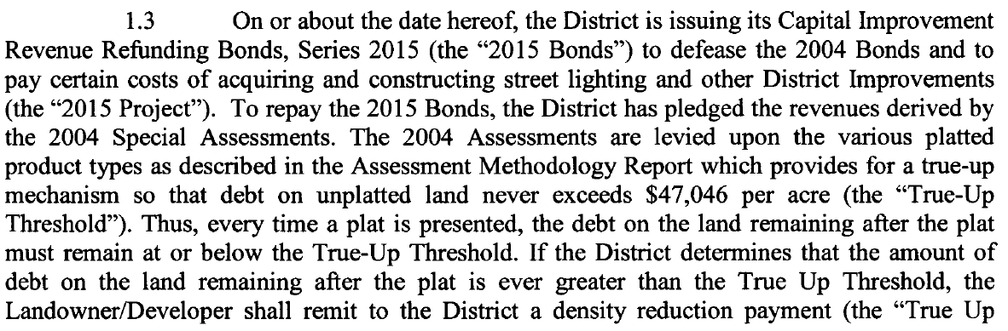

**\* * * \***

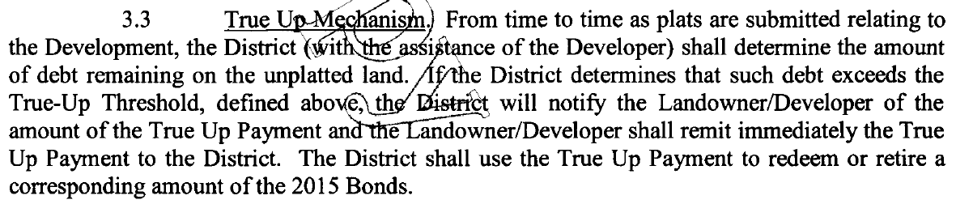

The True-Up Mechanism is described in the referenced 2004 Assessment Methodology Report, Exhibit C, which was completed by Severn Trent at the time that the 2004 Bond Series was issued, as follows:

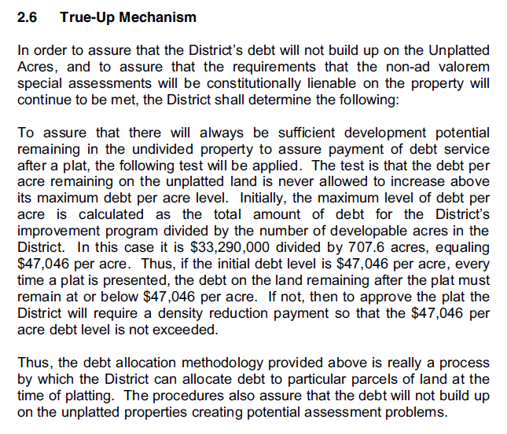

Additionally, the District’s performance of the True-Up analysis at the time of platting is discussed in another section of the 2004 Assessment Methodology Report:

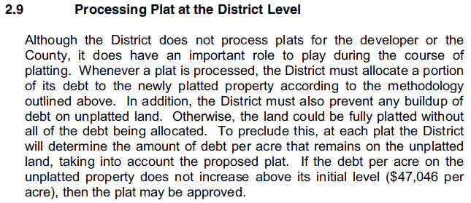

The purpose of a true-up mechanism is the prevent the buildup of debt on undeveloped property that could create future assessment problems. Here, the pertinent documents state that the District is to perform the True-Up analysis every time a plat is “presented” or “submitted.” In Osceola County, landowners are generally required to go through the formal platting process contained in Chapter 177, Florida Statutes, when they wish to subdivide land. Osceola County Land Development Code Chapter 2.1.1(I). Plats must be approved by the local governing body, which in this case is Osceola County, and are recorded following such approval. §§ 177.071, 177.111, Fla. Stat. (2017). Accordingly, we opine that the performance of the True-Up analysis by the District is required anytime that a plat is submitted to and approved by the County and then subsequently presented to the District by the Developer to allow the True-Up analysis to occur.

At the time that a plat is submitted, a certain amount of debt is allocated to the property within that plat. According to the documents, to perform the True-Up analysis the District must then determine if the amount of debt that will be allocated to the property that remains unplatted after the new plat exceeds the per acre threshold. If the per acre threshold is exceeded, the Developer is required to make a density reduction payment so that the threshold is no longer exceeded. In other words, the Developer is required to “buy-down” the debt on the remaining unplatted properties each time a plat is submitted.

For purposes of illustration: if you had a district made up of 100 acres and the total debt is $100, your per acre threshold is $1 per acre. If one neighborhood consisting of 25 acres is then platted and the total amount of the debt allocated to the neighborhood based on the maximum special assessment amount per lot is $20, then the debt on the remaining 75 unplatted acres is now $80. $80/75 unplatted acres=$1.067 per acre. The per acre threshold is exceeded on the unplatted acres after the submitted plat. Under the True-Up Agreement, the developer would be required to remit a $5 density reduction payment to bring the debt per acre amount on the remaining unplatted acres back down to $1. $80-$5=$75. $75/75 unplatted acres=$1 per acre.

To date, the District has never required a density reduction payment on the lands subject to the 2015 Bonds pursuant to the True-Up Mechanism. In 2007, large tracts of land subject to the 2015 (then 2004) Bonds were platted (including neighborhoods J, K, & L). Exhibit D. Additionally, two replats of some of the land included in the 2007 plat were also submitted and recorded in 2015 and 2016 (neighborhoods I & O-1), after the execution of the 2015 True-Up Agreement. Exhibits E & F. It is our opinion that the True-Up analysis should have been performed at each of those plats. It is also our opinion that a density reduction payment would have been due in 2007[1] (and, consequently, in 2015 and/or 2016) because the $47,046 per acre threshold would have been exceeded on the unplatted lands following the 2007 plat.

According to Severn Trent’s calculations, the debt per acre on the unplatted lands subject to the 2015 Bonds currently exceeds the $47,046 threshold. See Exhibit A (Excel Spreadsheet Tab 1). The 2015 True-Up Agreement states that: “If the District determines that the amount of debt on the land remaining after the plat is ***ever*** greater than the True Up Threshold, the Landowner/Developer shall remit to the District a density reduction payment (the “True Up payment”) so that the True Up Threshold is not exceeded and the District will use such payment to redeem or prepay the 2015 Bonds.” 2015 True-Up Agreement § 1.3 (emphasis added). Based on that language, we would recommend that the District now determine that the amount of debt on the unplatted acres remaining after the last plat (neighborhood O-1) exceeds the True-Up Threshold and a density reduction payment is required. According to Severn Trent’s calculations, the amount of the density reduction payment required to buy-down the debt on the unplatted acres subject to the 2015 Bonds is **$351,667.59**.[2]

When this question initially arose, there was some discussion about amending the 2015 True-Up Agreement to raise the amount of the True-Up Threshold—thus, reducing or possibly eliminating a density reduction payment on the unplatted lands subject to the 2015 Bonds. This is still an option that the Board could pursue. However, it would not be our recommended course of action because obtaining an amendment to the 2015 True-Up Agreement requires obtaining an opinion of bond counsel and the majority consent of the 2015 bondholders. Securing those two items would be a costly and time-consuming endeavor. Additionally, it is our opinion that raising the True-Up Threshold amount is not the proper method to remedy the buildup of debt that has occurred on the unplatted acres. Pursuant to the pertinent documents, requiring a density reduction payment under the True-Up Mechanism is the proper method to remedy the buildup of debt.

As to the lands subject to the 2014 Bonds, utilizing the same True-Up Mechanism but a different True-Up Threshold applicable to those lands, Severn Trent has determined that the Threshold is currently exceeded on the unplatted acres. Severn Trent has calculated that a density reduction payment in the amount of **$84,870.35** is due and payable. See Exhibit A (Excel Spreadsheet Tab 2). It is our understanding that the density reduction payment owed on the lands subject to the 2014 Bonds has not been disputed and accordingly, we were not asked to provide a legal analysis as to this payment. However, because it has now been determined that the Threshold amount for the unplatted acres subject to the 2014 Bonds has also been exceeded, we would recommend that the Board also make the determination that a density reduction payment is owed on the lands subject to the 2014 Bonds.

**Conclusion**

Based on the pertinent legal documents, each time a plat is submitted, the District must determine whether the debt remaining on the unplatted acres exceeds a certain per acre debt threshold. If the District determines that the per acre debt threshold is exceeded, the District shall require a density reduction payment from the Developer so that the per acre debt threshold is no longer exceeded on the unplatted acres. This True-Up analysis should have been performed each time there was a plat submitted for lands in the District.

To date, the District has not made such a determination and required a density reduction payment. However, we would recommend that because the debt per acre threshold is currently exceeded on the unplatted acres subject to both the 2014 and 2015 Bonds, the District should now determine that the threshold has been exceeded and that a density reduction payment is due and payable.

1. We do not know the exact payment that would have been due in 2007. We have been advised by Severn Trent that going back to 2007 to determine this number would require a full forensic analysis which could not occur prior to the September 14, 2017 meeting or before the Developer’s scheduled closing. However, it is our belief that the payment that would have been due in 2007 would have been higher than what is due today even if the number of “unplatted” acres is the same. This is because since 2007, there has been ten years’ worth of debt servicing paying down the principal amount of the debt.
2. At the last meeting, the Board will recall that there was discussion that the amount due exceeded $2,000,000.00. There was some initial confusion between Severn Trent and the Developer as to what constituted “platted” or “unplatted” lands for the purposes of this analysis. The $2 million figure was derived by including some parcels that have in fact been platted (*i.e.,* J, K, & L neighborhoods) into the equation as “unplatted” properties. However, according to the plain languge of the pertinent documents, these neighborhoods should not be included in the category of “unplatted” lands for the purposes of the True-Up analysis because plats for those lands have been submitted to and approved by Osceola County and now—at the latest—submitted to the District by the Developer.