**District Infrastructure**

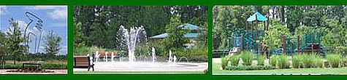

***Alleys & Sidewalks***.

In the neighborhoods that have them, alleys are maintained by the District. Sidewalk maintenance is a shared responsibility between homeowner & District. Appearance maintenance of sidewalks along the front and side of a property is the responsibility of the owner. For those walkways not adjacent to a residence, the District is responsible for appearance maintenance. The District is also responsible for structural integrity maintenance of all sidewalks and walkways throughout the community.

Appearance maintenance consists of sweeping and mold & mildew removal (via power washing &/or chemical application). Structural maintenance consists of elevated edge grinding, cracked edge or corner repair, and defective slab replacement, as needed.