1. **Prior Meeting Minutes Approval**

* 2015/11/19 Meeting [pp4-43] Agenda **Item 3** (no noteworthy issues identified)
* 2015/10/29 Workshop (see “**Developer Plans**” under ***Supervisor Requests*** below)

1. **Prepaid Assessments Review**

* Agenda **Item 4** [pηη] This item is **Missing** pre-meeting reviewable **Content!**

1. **Ponds Consultant Proposal**

* Agenda **Item 5A** [pp46-48] **Approve** proposal for initial period of one year.   
   Review results after one year for consideration of renewal.

1. **Facility Usage Application**

* Agenda **Item 8D** [pp136-138] **Approve** CFLC Easter Service in the Square.   
   Move to wave fee based on Worthy Cause and use history.

1. **Aggregate Agenda Items**

* Agenda **Item 2** [pηη] **Audience Comments** (meeting only content)
* Agenda **Item 5B** [pp50-54] **Davey Report** (no preview issues identified)
* Agenda **Item 6** [pηη] **Developer Report** (meeting only content)
* Agenda **Item 7A** [pg57] **Sidewalk Estimate** (probability of **extra $3K cost?**)
* Agenda **Item 7B** [pηη] **Attorney Report** (meeting only content)
* Agenda **Item 7Ci**&**iii** [pp59-60&64-67] **Docks** & **Boats** (no preview issues)
* Agenda **Item 7Cii** [pg62] **Facebook** (further info on **playground vandalism?**)
* Agenda **Item 8A** [pp69-84] **Financials** (no preview issues identified)
* Agenda **Item 8B** [pp86-131] **Expenditures** (no preview issues found)
* Agenda **Item 8C** [pp50-54] **Website** (filter & **stop showing robots.txt!**)

1. **Supervisor Requests**

* **Developer Plans** Make 10/29/15 Plans Presentation available to Residents.   
   [One option is to add a hyperlink to the [Workshop Minutes](../wMinutes/2015-10-29_Workshop.pdf).]   
   [Alternate is to add hyperlink to the [Workshops Webpage](../Workshops.htm).]
* **District Graphics** **Update** District **Maps**: **(1)** [**Site Plan**](../wGraphics/2015-Site-Plan.jpg); and **(2)** [**Street Names**](../wGraphics/2014-Street-Names.jpg).   
   Engage the District Engineer to revise Street Names map.   
   [These graphics appear On-Line & in Rules Appendix 3.]
* **Meeting Materials** All formal material used during meetings should be **available**   
   to District Residents **on-line** via District website hyperlinks.
* **Work with HROA** Have website admins, **Rose Meister** & **Brenda Burgess**, for   
   ROA & CDD, respectively, coordinate inter-site hyperlinks.
* **Irrigation System** What is the anticipated **availability date** of on-line maps?   
   Would aid in reviewing/checking TOHO water bill variations.
* **Potential Facilities** (see description, comments, and questions in **Item 7** below)

1. **Undeveloped Tract**

* Area Location Bounded by Schoolhouse, Butterfly, Galaxy, & Sundrop

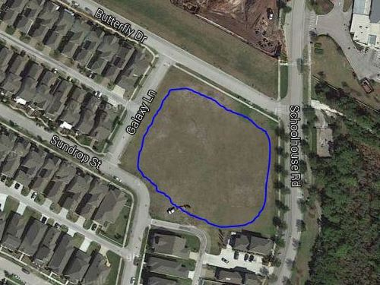

* Area Ownership Currently Developer property! District acquire/share it?
* Utilization Limited Currently used for school and personal overflow parking
* Usage Deficiencies Grading & fill needed to support structural development?
* Plausible Alternatives Softball Field, Skateboard Park, or Swim Facility (original)   
   Land requires nothing – except a commitment to use it!
* Development Budget Would seem to be an appropriate place for investment   
   Any possibility of cost sharing by District & Developer?
* Engineer Plat Layout Same detailed drawing quality as supplied for pipeline   
   Need “OK for Playground” confirmation by Engineer