1. **Aggregate Agenda Items**

* Agenda **Item 2** [pgηη] **Audience Comments** (meeting only content)
* Agenda **Item 3** [pp4-34] **Prior Meeting Minutes** – (no specific issues)
* Agenda **Item 5** [pgηη] **Quarterly**: 🡨 {Is **Schedule** regular or as-needed?}
* Agenda **Item 6A** [pgηη] **Engineer Report** (meeting only content)
* Agenda **Item 6B** [pgηη] **Attorney Report** (meeting only content)
* Agenda **Item 7A,B** [pp54-69;71-121] **Financials** **&** **Expenditures** – (no issues)
* Agenda **Item 7E** [pp131-140] **Arbitrage** – (no specific issues identified)
* Agenda **Item 7F** [pg142] **UOC Invoice** – (no specific issues identified)

1. **Subcontractor Reports**

* Agenda **Item 4A** [pgηη] **Aquatic Weeds** -- [no longer under Bio-Tech contract]   
  **Who makes report?** Will it be by **Field Manager** in future?
* Agenda **Item 4Bi** [pp37-42] **Davey Landscaping** – (one question identified)   
  [pg41] **PO# (pending)** – **Completed tasks** **w/o** **funding?**
* Agenda **Item 4Bii** [pgηη] **Proposals** – {Three new ones submitted by Davey}

1. **Filed Manager Report**

* Agenda **Item 6Ci,ii,**&**iii** [pp45-46;48;50 ] **Facilities**,**Facebook**,**&****Boats** – (no issues)
* Agenda **Item 6Civ** [pgηη] **Pontoon Boat** – **Oppose expenditure** at current time.
* Agenda **Item 6Cv** [pgηη] **Pond Consultant** – {Continuation of prior discussion}

1. **Usage Applications**

* Agenda **Item 7C** [pp123-125] **Approve** HSC **Easter Service** in Town Square.
* Agenda **Item 7D** [pp127-129] **Approve** ACS **Relay for Life** in Town Square.   
  {Only “**Issue**” is the **time span:** **12noon** -to- **12midnight?**}

1. **Supervisor Requests**

* **Meeting Materials** All material used during Board Meetings should be **on-line**.   
  [Public access is made via **hyperlinks** on District website.]
  + **District Graphics** [Graphics in **Rules Appendix**, so no Workshop to update.]   
    **Update** District **Maps**: **(1)** [**Site Plan**](../wGraphics/2015-Site-Plan.jpg); and **(2)** [**Street Names**](../wGraphics/2014-Street-Names.jpg).   
    Get Engineer (or Developer?) to revise Street Names map.
  + **Mtng Slideshows** Put **10/29/15** **Developer Presentation** on-line for Residents.   
    [Add hyperlink to [**Workshops Webpage**](../Workshops.htm) 🡨 (see example)]
* **CDD & ROA Websites** Have administrators, **Brenda Burgess** & **Rose Meister**, for CDD & ROA, respectively, coordinate inter-site hyperlinks.
* **Irrigation System** What is the anticipated **availability date** of on-line maps?   
  Would aid in reviewing/checking TOHO water bill variations.
* **Projector & Screen** Buy 16**:**9 aspect ratio (**cost:** projector <**$500**; screen <**$100**)
* **Potential Facilities** (see description, comments, & questions in **Item 6** below)

1. **Undeveloped Tract**

* Area Location Bounded by Schoolhouse, Butterfly, Galaxy, & Sundrop

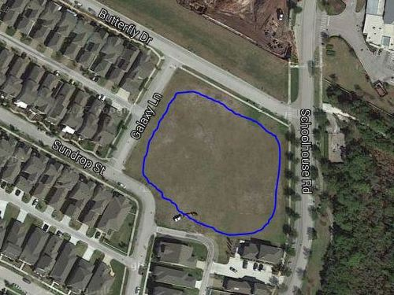

* Area Ownership Currently Developer property! District acquire/share it?
* Utilization Limited Currently used for school and personal overflow parking
* Usage Deficiencies Grading & fill needed to support structural development?
* Plausible Alternatives Softball Field, Skateboard Park, or Swim Facility (original)   
   Land requires nothing – except a commitment to use it!
* Development Budget Would seem to be an appropriate place for investment   
   Any possibility of cost sharing by District & Developer?
* Engineer Plat Layout Same detailed drawing quality as supplied for pipeline   
   Need “OK for Playground” confirmation by Engineer