1. **Aggregate Agenda Items**

* Agenda **Item 2** [pgηη] **Audience Comments** (meeting only content)
* Agenda **Item 3** [pp4-63] **Prior Meeting Minutes** – (no issues found)
* Agenda **Item 5** [pgηη] **Developer Quarterly**: 🡨 {None this month}
* Agenda **Item 6A** [pgηη] **Engineer Report** (meeting only content)
* Agenda **Item 6B** [pgηη] **Attorney Report** (meeting only content)   
  – **Legal Opine** on **Davey Contract Piggyback**ing Option**?**   
  – **Legal Opine**/Action on **Pond Consultant** **Waiver** Issue**?**

1. **District Manager Report**

* Agenda **Item 7A** [pp75-90] **Financial Statements** – (no issues) {1 question}**:**   
  – [pp89&90] Pages identical except for United Bank yield %?
* Agenda **Item 7B** [pp92-144] **Invoice Set #190** – (no issues) {1 minutia item}**:**   
  – [pg56] Town Center electric power 2X highest prior level?
* Agenda **Item 7C** [pp146-147] **Requisition 002** – **Approve** Pontoon Boat **$$**
* Agenda **Item 7D** [pgηη] **Use App** (TwnCntr Movie Night by HCC) – **Approve**
* Agenda **Item 7E** [pgηη] **Use App** (ScrFlds Practice by StCld SC) – **Approve**

1. **Subcontractor Reports**

* Agenda **Item 4Ai** [pp56-60] **Davey Landscaping** – (no issues identified)
* Agenda **Item 4Aii** [pgηη] Any follow to **Town Square Proposal** discussions?
* Agenda **Item 4B** [pgηη] **Aquatic Weed Control** – **Who now makes Report?**

1. **Field Manager Report**

* Agenda **Item 6Ci,ii,**&**iii** [pp63-70 ] **Facilities**,**Facebook**,**&****Boats** – (no issues ID’d)
* Agenda **Item 6Civ** [pg72] **Butterfly Sidewalk Proposal** – Has **cost** increased?

1. **Supervisor Requests**

* **Meeting Materials** Board Meeting **materials** should be **on-line** for Residents.
  + **Developer Plans** **10/29/15** **Developer Presentation** now available **on-line**.
  + **District Graphics** **Completed** – District **(1)** [**Trails Map**](../wGraphics/2016-Trails-Map.jpg) and **(2)** [**Site Plan**](../wGraphics/2016-Site-Plan.jpg);   
    **Need** -- **(3)** [**Street Names**](../wGraphics/2014-Street-Names.jpg) Map; **Engineer Cost Estimate**?

* **CDD & ROA Websites** Administrators **Brenda Burgess** / **Rose Meister** (CDD / ROA) to institute further **coordination** of inter-website hyperlinks.

* **Irrigation System** **Who** requested/authorized **removal** of information from web?   
  **When** is the anticipated **availability** date of the on-line maps?   
  **Aid** with **TOHO water bill** and in **system repair** **visualizing**.

* **Projector & Screen** **Buy** 16**:**9 aspect ratio (**cost:** projector <**$500**; screen <**$100**)   
  CDD ownership **assures** equipment access & **availability**.

* **Facilities Status** Plans to **repair/replace** damaged **picnic tables** in dogpark?   
  (see description, comments, & questions in **Item 6** below)

1. **Undeveloped Tract**

* Area Location Bounded by Schoolhouse, Butterfly, Galaxy, & Sundrop

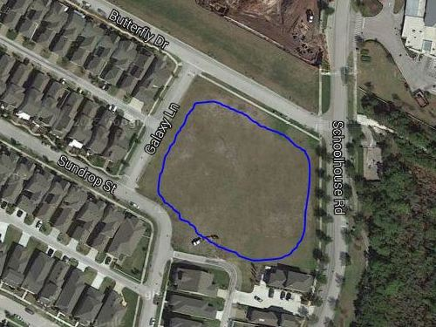

* Area Ownership Currently Developer property! District acquire/share it?
* Utilization Limited Currently used for school and personal overflow parking
* Usage Deficiencies Grading & fill needed to support structural development?
* Plausible Alternatives Softball Field, Skateboard Park, or Swim Facility (original)   
   Land requires nothing – except a commitment to use it!
* Development Budget Would seem to be an appropriate place for investment   
   Any possibility of cost sharing by District & Developer?
* Engineer Plat Layout Same detailed drawing quality as supplied for pipeline   
   Need “OK for Playground” confirmation by Engineer