* **Street Names Map** **District Engineer Task** – Any progress? Completion date?
* **Harmony DRI Map** [**Revised Boundary**](../rwGraphics/Rev'dHarmonyDRI.rot.crop.clr.jpg) – Will new graphic be made available?
* **Master Drainage** **Recent Updates** – Will a new graphic be made available?
* **ID Card Process** **Any Further Discussions?** – (payment process options)
* **Parcel Location** [**District Boundary Map**](../MtgPages/!Boundary-CDD.htm) – **Identify** Sites of Parcels **M**, **N**, **&** **O**.
* **Agenda Format** **Major Categories** – “**Topical Discussions**” category added!
* **Website Update** **Enhancements Completed** – Still Evaluating Maintenance.
* **Business Links** **Internet Websites** – Any besides Champions available?
* **Links** -by- **HROA** **Any Progress To Report?** – (from FSR site coordinator)
* **Irrigation System** **Revised Webpage Verbiage** – Stipulates service personnel.
* **Projector & Screen** **Buy** 16**:**9 aspect ratio (**cost:** projector <**$500**; screen <**$100**)   
  CDD ownership **assures** equipment access & **availability**.

1. **Undeveloped Tract**

* Area Location Bounded by Schoolhouse, Butterfly, Galaxy, & Sundrop

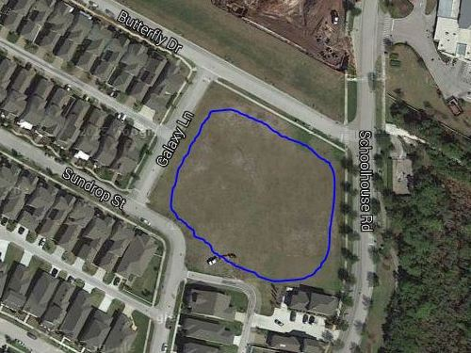

* Area Ownership Currently Developer property! District acquire/share it?
* Utilization Limited Currently used for school and personal overflow parking.
* Usage Deficiencies Grading & fill needed to support structural development?
* Plausible Alternatives Softball Field, Skateboard Park, or Swim Facility (original).   
   Land requires nothing – except a commitment to use it!
* Development Budget Would seem to be an appropriate place for investment.   
   Any possibility of cost sharing by District & Developer?
* Engineer Plat Layout Same detailed drawing quality as supplied for pipeline.   
   Need “OK for Playground” confirmation by Engineer.