* **Master Drainage Map** **District Engineer** – How obtain unique color ponds map?   
  **Harmony “DRI” Map** **District Engineer** – How obtain unique color details map?   
  **CDD Boundary Map** **District Engineer** – Do all identify **Parcels** [**A** thru **O**] **IDs**?   
  **Street Names Map** **District Engineer** – How obtain unique color streets map?
* [**Boulevard Trees**](../PerMtgPgs/Tree-Intrusions.htm) **Maintenance** – Encroachment will cause increasing costs!   
  **Replacement** – Possible use of magnolias on houses side.
* **Inter-Website Links** **Any Further Progress?** – (Input from FSR site coordinator)
* **Harmony Directories** **Resident Business** – Any volunteers to undertake update?   
  **Resident Names** – Any options for comprehensive version?
* **Projector & Screen** **Buy** 16**:**9 aspect ratio (**cost:** projector <**$500**; screen <**$100**)   
  CDD ownership **assures** equipment access & **availability**.

**Undeveloped Tract**

* Area Location Bounded by Schoolhouse, Butterfly, Galaxy, & Sundrop

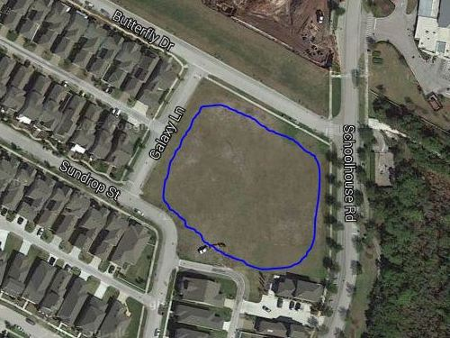

* Area Ownership Currently Developer property! District acquire/share it?
* Utilization Limited Currently used for school and personal overflow parking
* Usage Deficiencies Grading & fill needed to support structural development?
* Plausible Alternatives Softball Field, Skateboard Park, or Swim Facility (original)   
   Land requires nothing – except a commitment to use it!
* Development Budget Would seem to be an appropriate place for investment   
   Any possibility of cost sharing by District & Developer?
* Engineer Plat Layout Same detailed drawing quality as supplied for pipeline   
   Need “OK for Playground” confirmation by Engineer