* [**Street Names Map**](../MtgPages/!Street-Names'16.htm) **Font Size & Line Weight** – Need to **increase** for **readability**.   
  **Pond Color Differences** – Why? **Dark blue** ID’s **unreadable!**
* **Boulevard Trees** **Cost of Maintenance** – Continuing, short-term, & long-term:   
  Believe **savings are realizable** by changing the type of tree.
* **Paved Walkway** **Behind Neighborhood F** – **Cost** to Install? (source: Kassel)
* **Projector & Screen** **Buy** 16**:**9 aspect ratio (**cost:** projector <**$500**; screen <**$100**)   
  CDD ownership **assures** equipment access & **availability**.
* **Harmony Directories** **Resident Business** – Has Developer initiated an update?   
  **Resident Names** – Any possibility of a complete version?

**Undeveloped Tract**

* Area Location Bounded by Schoolhouse, Butterfly, Galaxy, & Sundrop

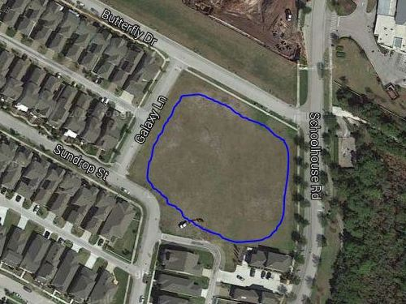

* Area Ownership Currently Developer property! District acquire/share it?
* Utilization Limited Currently used for school and personal overflow parking
* Usage Deficiencies Grading & fill needed to support structural development?
* Plausible Alternatives Softball Field, Skateboard Park, or Swim Facility (original)   
   Land requires nothing – except a commitment to use it!
* Development Budget Would seem to be an appropriate place for investment   
   Any possibility of cost sharing by District & Developer?
* Engineer Plat Layout Same detailed drawing quality as supplied for pipeline   
   Need “OK for Playground” confirmation by Engineer