* **Streetlight Loans** **Pay-Down Timing** – When are sufficient **funds available?**   
  **Loans Remaining** – **#s 1**-**4 & 7**-**9** – As before [**ROI varies!**](StreetlightLoans_BuyoutROI.pdf)   
  **Planning Decision** needed to capitalize on opportunities.
* **Community Artwork** **Deteriorated Condition** – Potential safety & liability [**Issue**](HarmonyArtwork_Issues.pdf):   
  Clarify **ownership responsibility** and refurbishment costs.   
  Is there any **information** available **from** original **sculptor?**
* **Street Names Map** **Font Size & Line Weight** – Need to **increase** for **readability**.   
  **Pond Colors** – **Change** **Dark Blue** to make **ID’s readable!**   
  **Issue** must ultimately be **addressed by**/with the **Engineer**.
* **Boulevard Trees** **Cost of Maintenance** – Continuing, short-term, & long-term:   
  Believe **savings is realizable** by changing the type of trees.   
  Was **Supervisor Kassel** assigned to explore **tree options?**
* **Projector & Screen** **Buy** 16**:**9 aspect ratio (**cost:** projector <**$500**; screen <**$100**)   
  CDD ownership **assures** equipment access & **availability**.
* **Harmony Directories** **Resident Business** – Has Developer initiated an update?   
  **Resident Names** – Any possibility of a complete version?
* **Walking Pathway** **Behind Neighborhood F** – **Cost** to Update? (source: Kassel)

**Undeveloped Tract**

* Area Location Bounded by Schoolhouse, Butterfly, Galaxy, & Sundrop

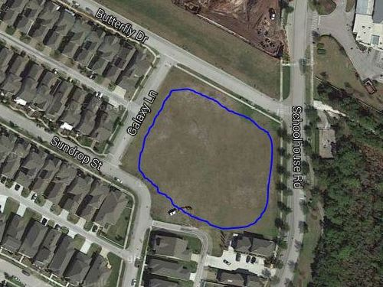

* Area Ownership Currently Developer property! District acquire/share it?
* Utilization Limited Currently used for school and personal overflow parking
* Usage Deficiencies Grading & fill needed to support structural development?
* Plausible Alternatives Softball Field, Skateboard Park, or Swim Facility (original)   
   Land requires nothing – except a commitment to use it!
* Development Budget Would seem to be an appropriate place for investment   
   Any possibility of cost sharing by District & Developer?
* Engineer Plat Layout Same detailed drawing quality as supplied for pipeline   
   Need “OK for Playground” confirmation by Engineer