* **Tablet Replacement** **Good to Go!** – Needed functionality of standard **laptop pc**.   
  Procurement & setup went smoothly – Tonight is **acid test!**
* **Streetlight Loans** **Pay-Down Timing** – Need Planning for **Optimum Benefit!**   
  **Loans Remaining** – **#s 1**-**4 & 7**-**9** – As before **ROI varies!**
* **Community Artwork** **Deteriorating Condition** – Beautification & liability **issues**:   
  **Ownership** & responsibility now **clearly** assumed by **CDD?**
* **Graphics Currency** **Version Availability** – Need to **update** District **documents**.   
  **Issue** must ultimately be **addressed by**/with the **Engineer**.
* **Street Names Map** **Font Size & Line Weight** – Need to **increase** for **readability**.   
  **Pond Colors** – **Change** **Dark Blue** to make **ID’s readable!**
* **Projector & Screen** **Buy** 16**:**9 aspect ratio (**cost:** projector <**$500**; screen <**$100**)   
  CDD ownership **assures** equipment access & **availability**.
* **Harmony Directories** **Resident Business** – Has Developer initiated an update?   
  **Resident Names** – Any possibility of a complete version?
* **Boulevard Trees** **Cost of Maintenance** – Continuing, short-term, & long-term:   
  Believe **savings is realizable** by changing the type of trees.
* **Walking Pathway** **Behind Neighborhood F** – **Cost** to update? (source: Kassel)

1. **Undeveloped Tract**

* Area Location Bounded by Schoolhouse, Butterfly, Galaxy, & Sundrop

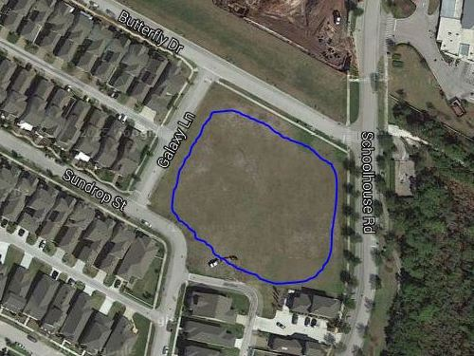

* Area Ownership Currently Developer property! District acquire/share it?
* Utilization Limited Currently used for school and personal overflow parking
* Usage Deficiencies Grading & fill needed to support structural development?
* Plausible Alternatives Softball Field, Skateboard Park, or Swim Facility (original)   
   Land requires nothing – except a commitment to use it!
* Development Budget Would seem to be an appropriate place for investment   
   Any possibility of cost sharing by District & Developer?
* Engineer Plat Layout Same detailed drawing quality as supplied for pipeline   
   Need “OK for Playground” confirmation by Engineer