**The Proposed Change IS:**

Break with the sixteen (16) year (2003 thru 2018) historical precedent of providing “*Near Verbatim*” Transcriptions of Meeting Minutes for current & future reference in favor of “*Summary*” Minutes which eliminate individual statements & quotations.

**The Question Then Posed IS:**

What does the Harmony District gain, how do Harmony Communities benefit, what do Harmony Residents gain, from the abandonment of “*Near Verbatim*” Minutes?

**The Question Posed IS NOT:**

What does the Harmony Board gain, how do individual Supervisors benefit, what do Employees of the District gain, through the adoption of “*Summary*” Minutes?

**My Answers & Opinions ARE:**

This topic results from paranoid fear by individual Board Members of the possibility of being misquoted &/or accurately quoted and then called-out on a misstatement when someone (Resident or otherwise) reviews fully transcribed (quoted) Minutes.

Citing “*Discovery*”, which is a Legal term, as a potential concern is a smokescreen (*Faux* News) thrown in to confuse the issue. If that is ever a real concern, there is an available remedy – it is called a “*Closed Session*” of the Board – to discuss any matters that have Legal ramifications to the Board, the District, or to Residents.

Accordingly, consideration of the radical change to “*Summary*” Minutes should be rejected & “*Near Verbatim*” Minutes Transcription should continue to be provided.

* **Engineering Report** **2012 Version Outdated** – Need to **Correct Parcel Zoning!**   
  **Exhibit-4 Map Wrong** for BL1, H1, H2, O, & Possibly Others.
* **Street Names Map** **Font Size & Line Weight** – Should **increase** for **readability**.   
  **Pond Colors** – **Change** **Dark Blue** to make **ID’s readable!**
* **Graphic Updates** **Version Availability** – Need to **Revise** District **Documents**.   
  **Engineer** to make **Fall Update** & add new **Neighborhoods**.
* **Future Facilities** **Building Escrow Fund** – Include **Placeholder** in **Budget!**   
  **Make Yearly Contributions** – **Starting** In Fiscal Year **2020!**   
  {Contingent on Loan Payoff in 2019 & Land being Available}
* **RC Camera Drone** **Buy** ≥10Mp HD camera (**cost:** helicopter system **≈$1000**)   
  CDD ownership **enables** on-demand facilities **monitoring**.

{ View Fields, Trails, Boats, Docks, Lakes, & Ponds }

* **Projector & Screen** **Buy** 16**:**9 aspect ratio (**cost:** projector **≈$500**; screen **≈$100**)   
  CDD ownership **assures** equipment access & **availability**.

{ Procurement May Become Critical With Developer Change }

* **Resident Directory** **Resident Business** – Has Developer initiated an update?   
  **Resident Names** – Any possibility of a complete version?
* **Community Artwork** **Deteriorating Condition** – Beautification & liability **issues**:   
  **Ownership** & responsibility now **clearly** assigned to **CDD?**
* **Walking Pathway** **Behind Neighborhood F** – **Cost** to update? (source: Kassel)
* **Boulevard Trees** **Cost of Maintenance** – Continuing, short-term, & long-term:   
  Final count of **mature trees** to **replace** due to **Irma** damage**?**

**Undeveloped Tract**

* Area Location Bounded by Schoolhouse, Butterfly, Galaxy, & Sundrop

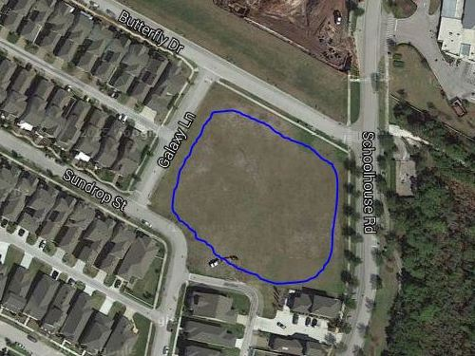

* Area Ownership Currently Developer property! District acquire/share it?
* Utilization Limited Currently used for school and personal overflow parking
* Usage Deficiencies Grading & fill needed to support structural development?
* Plausible Alternatives Softball Field, Skateboard Park, or Swim Facility (original)   
   Land requires nothing – except a commitment to use it!
* Development Budget Would seem to be an appropriate place for investment   
   Any possibility of cost sharing by District & Developer?
* Engineer Plat Layout Same detailed drawing quality as supplied for pipeline   
   Need “OK for Playground” confirmation by Engineer