1. Who is the developer (or, who are the developers, if there is more than one) who are currently still active in Harmony?
2. Why does the discussion of possible uses of the VC1 parcel appear under the heading of “*Developer’s Report*”? Are we now the “*Developer*”?
3. Why is the “*Developer’s Report*” still in the #2 position in the Agenda Order-of-Business? It was originally moved up there as a “courtesy” to Mr. Jerman.
4. Since neither he nor any other developer is contributing to the Topic, it should be dropped back down in the Order of Business (possibly to the bottom).
5. If subjects like the VC1 Parcel you to be discussed early in the meeting, then select a major Topic “title” that is appropriate; the *Developer’s Report* is not!!!
6. Why is a “*permanent place for Field Services*” still an issue? I thought that the Board had authorized the purchase of a new trailer. If we are renting, why? If we need a concrete slab to set the trailer on, then install it, buy a trailer, & set it on it. What “additional” expenditure of funds are you angling for?
7. Multiple times you have been called-to-task by former and current members of this board for the overbearing, belligerent, & condescending way that you treat people and go about things. That was in the past. Now it seems you feel you can do it with impunity because you have a “brain-washed” cabal to back you.
8. You have a demonstrated propensity for deprecating anything that you did not originate and anyone who disagrees with you. Can you define “*deprecate*”? It means to *disparage* and *belittle*; and when confronted, you are quite good at it.
9. I will give you your “due”; there are places and conditions where you do things that that are without peer. Unfortunately, you are intemperate, and there are far too many situations where you are do not do right; and refuse to see it.

* **Future Facilities** **Building Escrow Fund** – Include **Placeholder** in **Budget!**   
  **Make Yearly Contributions** – **Starting** In Fiscal Year **2020!**

{ **Land** Available and Streetlight **Loan Payoff** Done }

* **Walking Pathway** **Behind Neighborhood F** – **Cost** to update; **funding** source**?**   
  Would serve as **Feeder Path** to new **Boardwalks** and **Piers**.
* **Engineering Report** **2012 Version Outdated** – Need to **Correct Parcel Zoning!**   
  **Exhibit-4 Map Wrong** for BL1, H1, H2, O, VC1, & Others.
* **Street Names Map** **Font Size & Line Weight** – Should **increase** for **readability**.   
  **Pond Colors** – **Change** **Dark Blue** to make **ID’s readable!**
* **Graphic Updates** **Version Availability** – Need to **Revise** District **Documents**.   
  **Engineer** to make **Fall Update** & add new **Neighborhoods**.
* **RC Camera Drone** **Buy** ≥10Mp HD camera (**cost:** helicopter system **≈$1000**)   
  CDD ownership **enables** on-demand facilities **monitoring**.

{ View Fields, Trails, Boats, Docks, Lakes, & Ponds }

* **Projector & Screen** **Buy** 16**:**9 aspect ratio (**cost:** projector **≈$500**; screen **≈$100**)   
  CDD ownership **assures** equipment access & **availability**.

{ Procurement May Become Critical With Developer Change }

* **Resident Directory** **Resident Business** – Has Developer initiated an update?   
  **Resident Names** – Any possibility of a complete version?
* **Community Artwork** **Deteriorating Condition** – Beautification & liability **Issues**:   
  **Ownership** & responsibility now **clearly** assigned to **CDD?**
* **Developer Liaison** **Authorization** – Board member contact outside of meetings:   
  Is member acting in that role designated to do so by Board?  
  To **formalize** process, **Move** that **Chairman** be designated**!**

**Undeveloped Tract**

* Area Location Bounded by Schoolhouse, Butterfly, Galaxy, & Sundrop

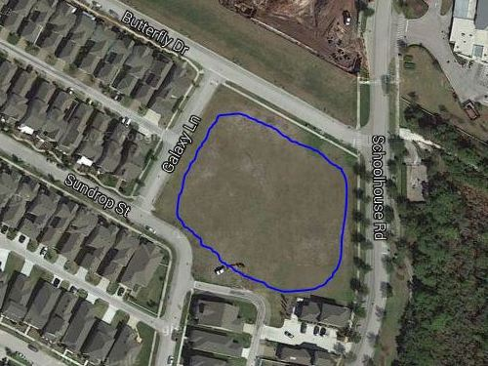

* Area Ownership Currently Developer property! District acquire/share it?
* Utilization Limited Currently used for school and personal overflow parking
* Usage Deficiencies Grading & fill needed to support structural development?
* Plausible Alternatives Softball Field, Skateboard Park, or Swim Facility (original)   
   Land requires nothing – except a commitment to use it!
* Development Budget Would seem to be an appropriate place for investment   
   Any possibility of cost sharing by District & Developer?
* Engineer Plat Layout Same detailed drawing quality as supplied for pipeline   
   Need “OK for Playground” confirmation by Engineer