1. Regarding the “Developer’s Report” in the meeting Agenda ToC:
   1. Who is the developer (or, who are the developers, if there is more than one) who are currently still active in Harmony?
   2. Why does the discussion of possible uses of the VC1 parcel appear under the heading of “*Developer’s Report*”? Are we the “*Developer*”?
   3. Why is the “*Developer’s Report*” still in position #2 of the Agenda Order-of-Business? It was placed there as a “courtesy” to Mr. Jerman.
   4. Since neither he nor any other developer is contributing to the Topic, it should be moved down in the Order of Business (possibly near bottom).
   5. If subjects like the VC1 Parcel warrant discussion early in the meeting, then place it under an appropriate Topic “title”; not *Developer’s Report* !!!
2. Regarding the issue of “sales” at the Swim Club Pool, it is to be noted that any activity that occurs at any District Facility, which deviates from or alters in any way the normal operation of that facility, must be considered a “Special Event” and accordingly be subject to all regulations associated with such “Events”.
3. In the past, the CCD Board has made a special effort to accommodate local businesses in any endeavor they undertake within Harmony boundaries. This has included the “waiving” of fees associated with an “Event” and taking a less formal approach to the “approval” of an “Event” when it is deemed in the best interest of the community.
4. With the placement of “signs” in the form of “menus” and the sale of food on the Pool premises without specifically noticed permission of any type being sought, this simple decorum, based on civility and mutual respect, has been abrogated – and must, of necessity, be addressed.
5. The means of “articulating/treating/correcting” the infraction is what must be established and executed. My opinion in this regard is as follows:
   1. No modification of CDD “Rules” is necessary, only the enforcement of requirements that are already in-place for “Special Events”;
   2. All “signs” (menus) of any kind that are not part of the normal signage of the installation must be removed and all “sales” of any kind halted;
   3. No resumption of any activity of any kind by any party will be permitted until such time as the affected party appeals to the District Board;
   4. Such applications/appeals must be made formally, either by personal appearance or document submission, at a duly noticed public meeting;
   5. Upon discussion and review by the Board, an Approval/Denial motion will be made, recorded, delivered, and appropriately actioned.

* **Future Facilities** **Building Escrow Fund** – Include **Placeholder** in **Budget!**   
  **Make Yearly Contributions** – **Starting** In Fiscal Year **2020!**

{ **Land** Available and Streetlight **Loan Payoff** Done }

* **Walking Pathway** **Behind Neighborhood F** – **Cost** to update; **funding** source**?**   
  Would serve as **Feeder Path** to new **Boardwalks** and **Piers**.
* **Engineering Report** **2012 Version Outdated** – Need to **Correct Parcel Zoning!**   
  **Exhibit-4 Map Wrong** for BL1, H1, H2, O, VC1, & Others.
* **Street Names Map** **Font Size & Line Weight** – Should **increase** for **readability**.   
  **Pond Colors** – **Change** **Dark Blue** to make **ID’s readable!**
* **Graphic Updates** **Version Availability** – Need to **Revise** District **Documents**.   
  **Engineer** to make **Fall Update** & add new **Neighborhoods**.
* **RC Camera Drone** **Buy** ≥10Mp HD camera (**cost:** helicopter system **≈$1000**)   
  CDD ownership **enables** on-demand facilities **monitoring**.

{ View Fields, Trails, Boats, Docks, Lakes, & Ponds }

* **Projector & Screen** **Buy** 16**:**9 aspect ratio (**cost:** projector **≈$500**; screen **≈$100**)   
  CDD ownership **assures** equipment access & **availability**.

{ Procurement May Become Critical With Developer Change }

* **Resident Directory** **Resident Business** – Has Developer initiated an update?   
  **Resident Names** – Any possibility of a complete version?
* **Community Artwork** **Deteriorating Condition** – Beautification & liability **Issues**:   
  **Ownership** & responsibility now **clearly** assigned to **CDD?**
* **Developer Liaison** **Authorization** – Board member contact outside of meetings:   
  Is member acting in that role designated to do so by Board?  
  To **formalize** process, **Move** that **Chairman** be designated**!**

**Undeveloped Tract**

* Area Location Bounded by Schoolhouse, Butterfly, Galaxy, & Sundrop

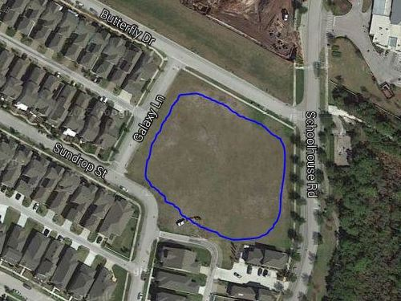

* Area Ownership Currently Developer property! District acquire/share it?
* Utilization Limited Currently used for school and personal overflow parking
* Usage Deficiencies Grading & fill needed to support structural development?
* Plausible Alternatives Softball Field, Skateboard Park, or Swim Facility (original)   
   Land requires nothing – except a commitment to use it!
* Development Budget Would seem to be an appropriate place for investment   
   Any possibility of cost sharing by District & Developer?
* Engineer Plat Layout Same detailed drawing quality as supplied for pipeline   
   Need “OK for Playground” confirmation by Engineer