1. As an alternative to Counsel’s PROPOSED SAMPLE POLICY re: solicitations on District property, a subject matter template was customized and is offered for consideration as a more generalized form of Solicitation (or “*No-Soliciting*”, if you prefer) Policy for both employees and non-employees (*i.e.*, general public).
2. In reading through Counsel’s analysis of **HB279**, it appears that it may be time for the District to acknowledge that, in addition to a Field Services Operations Manager, it also needs a Field Services Office Manager with the necessary skill set to keep fastidious track of expenditures and work performed. This would also address the concerns of **HB5003**, Section 108. I tried to cite this need several months ago but the whole idea was pooh-poohed at that time.
3. I believe that I asked this before: Exactly how many ADA based lawsuits have there been against CDDs in Florida (regardless of reason)? I have tried but can find no list of any such lawsuits. I would like to study their details. I am not interested in suits against any other form of local government; only CDDs! This all plays into the ongoing hysteria regarding the “compliance” of CDD websites. In my opinion, it smacks of a Mafia “protection racket” shakedown.
4. I am discouraged that no update is available regarding a renewed agreement for the use of, and maintenance of, Central Bark. Philosophically, I still prefer that alternative to the construction of an entirely new dog park.
5. What is the status of the “New Playground Equipment”? As cited in Kristen’s notes, the subject was supposed to be on the Agenda, but it is not listed.
6. Similarly, what is the status of the District’s fund transfers to United Bank?
7. Inclusion of “another” discussion of the VC-1 Parcel is intended to elicit ideas for its productive use; not serve as a platform for dictating what the use should be. To kick of the batting around of ideas, consider this option: Since $1M for a dedicated, specially built, new Community Center facility is not in the offing due to budget constraints, what about a used, double-wide trailer, including setup and installation, for less than 1/10th of that (guesstimate cost is **≈**$60K)?
   1. This would provide an immediate meeting place for the CDD, HOA, boy scouts, girl scouts, planning committees, and other community groups.
   2. It would also provide a place for community “Special Events”; like maybe an old fashioned “Ice-Cream Social” [couldn’t resist; would love to see it]?
8. Regarding Supervisor Scarborough’s request for a new park bench, the only drawback I see is the site’s proximity to the Golf Course’s golf cart path.

* **Future Facilities** **Building Escrow Fund** – Include **Placeholder** in **Budget!**   
  **Make Yearly Contributions** – **Starting** In Fiscal Year **2020!**

{ **Land** Available and Streetlight **Loan Payoff** Done }

* **Walking Pathway** **Behind Neighborhood F** – **Cost** to update; **funding** source**?**   
  Would serve as **Feeder Path** to new **Boardwalks** and **Piers**.
* **Engineering Report** **2012 Version Outdated** – Need to **Correct Parcel Zoning!**   
  **Exhibit-4 Map Wrong** for BL1, H1, H2, O, VC1, & Others.
* **Street Names Map** **Font Size & Line Weight** – Should **increase** for **readability**.   
  **Pond Colors** – **Change** **Dark Blue** to make **ID’s readable!**
* **Graphic Updates** **Version Availability** – Need to **Revise** District **Documents**.   
  **Engineer** to make **Fall Update** & add new **Neighborhoods**.
* **RC Camera Drone** **Buy** ≥10Mp HD camera (**cost:** helicopter system **≈$1000**)   
  CDD ownership **enables** on-demand facilities **monitoring**.

{ View Fields, Trails, Boats, Docks, Lakes, & Ponds }

* **Projector & Screen** **Buy** 16**:**9 aspect ratio (**cost:** projector **≈$500**; screen **≈$100**)   
  CDD ownership **assures** equipment access & **availability**.

{ Procurement May Become Critical With Developer Change }

* **Resident Directory** **Resident Business** – Has Developer initiated an update?   
  **Resident Names** – Any possibility of a complete version?
* **Community Artwork** **Deteriorating Condition** – Beautification & liability **Issues**:   
  **Ownership** & responsibility now **clearly** assigned to **CDD?**
* **Developer Liaison** **Authorization** – Board member contact outside of meetings:   
  Is member acting in that role designated to do so by Board?  
  To **formalize** process, **Move** that **Chairman** be designated**!**

**Undeveloped Tract**

* Area Location Bounded by Schoolhouse, Butterfly, Galaxy, & Sundrop

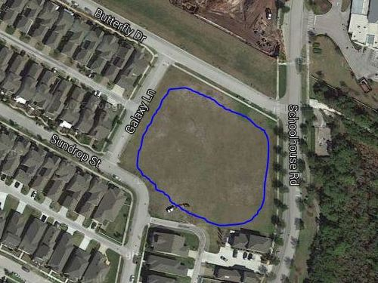

* Area Ownership Currently Developer property! District acquire/share it?
* Utilization Limited Currently used for school and personal overflow parking
* Usage Deficiencies Grading & fill needed to support structural development?
* Plausible Alternatives Softball Field, Skateboard Park, or Swim Facility (original)   
   Land requires nothing – except a commitment to use it!
* Development Budget Would seem to be an appropriate place for investment   
   Any possibility of cost sharing by District & Developer?
* Engineer Plat Layout Same detailed drawing quality as supplied for pipeline   
   Need “OK for Playground” confirmation by Engineer