1. As an alternative to Counsel’s PROPOSED SAMPLE POLICY re: Solicitations on District Property, I customized an industry standard template and offer it for consideration as a more generalized form of Solicitation (or “*No-Soliciting*”, if you prefer) Policy for both employees and non-employees (*i.e.*, general public). It is an expansion and clarification of the District’s [Employee Policy Manual, Section VI, Paragraph H](http://www.harmonycdd.org/Library/MscDoc/Policy/HCDD_EmployeePolicyManual.pdf#page=12); titled “*Solicitations/Distributions*”.
2. Inclusion of “another” discussion of the VC-1 Parcel is intended to elicit ideas for its productive use; not serve as a platform for dictating what the use should be. To kick of the batting around of ideas, consider this option: Since $1M for a dedicated, specially built, new Community Center facility is not in the offing due to budget constraints, what about a used, double-wide trailer, including setup and installation, for less than 1/10th of that (guesstimate cost is **≈**$60K)?
   1. This would provide an immediate meeting place for the CDD, HOA, boy scouts, girl scouts, planning committees, and other community groups.
   2. It would also provide a place for community “Special Events”; like maybe an old fashioned “Ice-Cream Social” [couldn’t resist; would love to see it]?
3. I am discouraged that no update is available regarding a renewed agreement for the use of, and maintenance of, Central Bark. Philosophically, I still prefer that alternative to the construction of an entirely new dog park.
4. I believe that I asked this before: Exactly how many ADA based lawsuits have there been against CDDs in Florida (regardless of reason)? I have tried but can find no list of any such lawsuits. I would like to study their details. I am not interested in suits against any other form of local government; only CDDs! This all plays into the ongoing hysteria regarding the “compliance” of CDD websites. In my opinion, it smacks of a Mafia “protection racket” shakedown.
5. Pursuant to Counsel’s analysis last month of **HB279**, it may prudent for the District to recognize that, in addition to a Field Services Operations Manager, it also needs a Field Services Office Manager with the necessary skill set to accurately document the District’s expenditures & work performed. This would also address the concerns of **HB5003**, Section 108. I have tried to cite this need on multiple occasions, but the suggestion has been repeatedly dismissed.

* **Future Facilities** **Building Escrow Fund** – Include **Placeholder** in **Budget!**   
  **Make Yearly Contributions** – **Starting** In Fiscal Year **2020!**

{ **Land** Available and Streetlight **Loan Payoff** Done }

* **Walking Pathway** **Behind Neighborhood F** – **Cost** to update; **funding** source**?**   
  Would serve as **Feeder Path** to new **Boardwalks** and **Piers**.
* **Engineering Report** **2012 Version Outdated** – Need to **Correct Parcel Zoning!**   
  **Exhibit-4 Map Wrong** for BL1, H1, H2, O, VC1, & Others.
* **Street Names Map** **Font Size & Line Weight** – Should **increase** for **readability**.   
  **Pond Colors** – **Change** **Dark Blue** to make **ID’s readable!**
* **Graphic Updates** **Version Availability** – Need to **Revise** District **Documents**.   
  **Engineer** to make **Fall Update** & add new **Neighborhoods**.
* **RC Camera Drone** **Buy** ≥10Mp HD camera (**cost:** helicopter system **≈$1000**)   
  CDD ownership **enables** on-demand facilities **monitoring**.

{ View Fields, Trails, Boats, Docks, Lakes, & Ponds }

* **Projector & Screen** **Buy** 16**:**9 aspect ratio (**cost:** projector **≈$500**; screen **≈$100**)   
  CDD ownership **assures** equipment access & **availability**.

{ Procurement May Become Critical With Developer Change }

* **Resident Directory** **Resident Business** – Has Developer initiated an update?   
  **Resident Names** – Any possibility of a complete version?
* **Community Artwork** **Deteriorating Condition** – Beautification & liability **Issues**:   
  **Ownership** & responsibility now **clearly** assigned to **CDD?**
* **Developer Liaison** **Authorization** – Board member contact outside of meetings:   
  Is member acting in that role designated to do so by Board?  
  To **formalize** process, **Move** that **Chairman** be designated**!**

**Undeveloped Tract**

* Area Location Bounded by Schoolhouse, Butterfly, Galaxy, & Sundrop

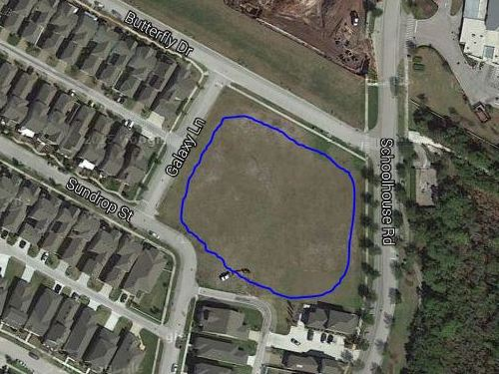

* Area Ownership Currently Developer property! District acquire/share it?
* Utilization Limited Currently used for school and personal overflow parking
* Usage Deficiencies Grading & fill needed to support structural development?
* Plausible Alternatives Softball Field, Skateboard Park, or Swim Facility (original)   
   Land requires nothing – except a commitment to use it!
* Development Budget Would seem to be an appropriate place for investment   
   Any possibility of cost sharing by District & Developer?
* Engineer Plat Layout Same detailed drawing quality as supplied for pipeline   
   Need “OK for Playground” confirmation by Engineer