**Log Sculpture On Cat Brier Trail At Front Of Dog Park**

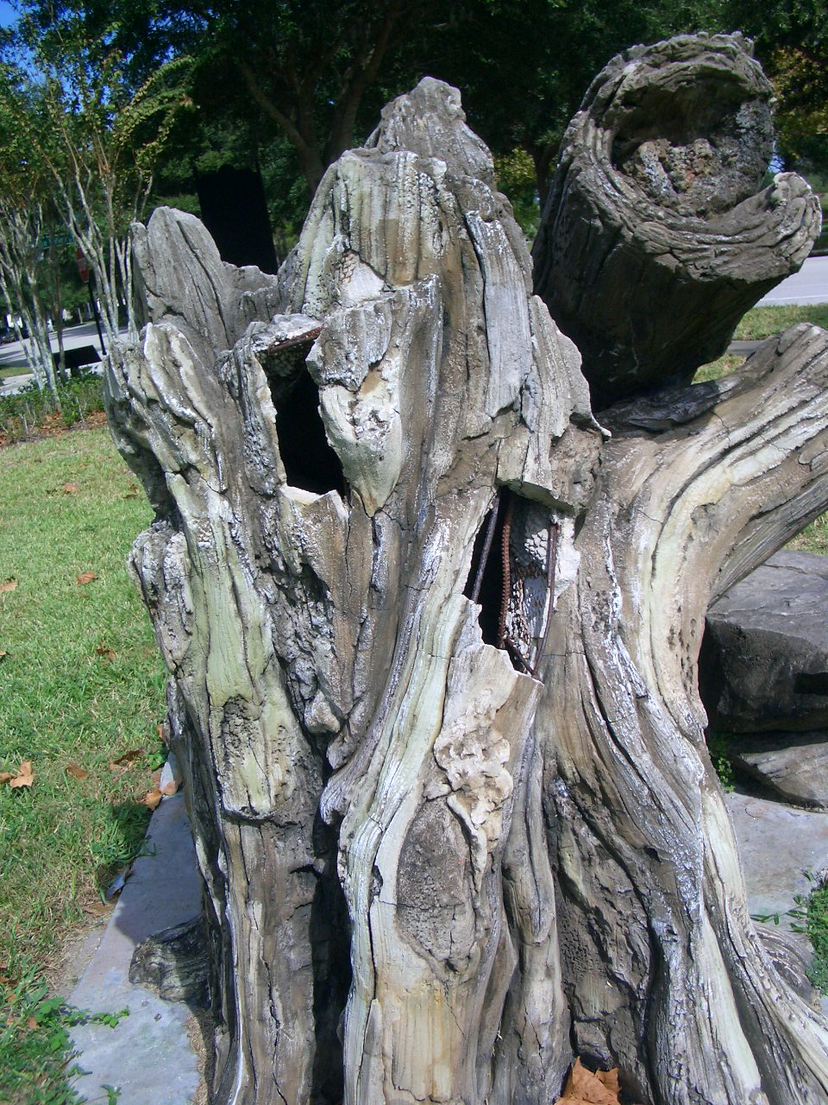

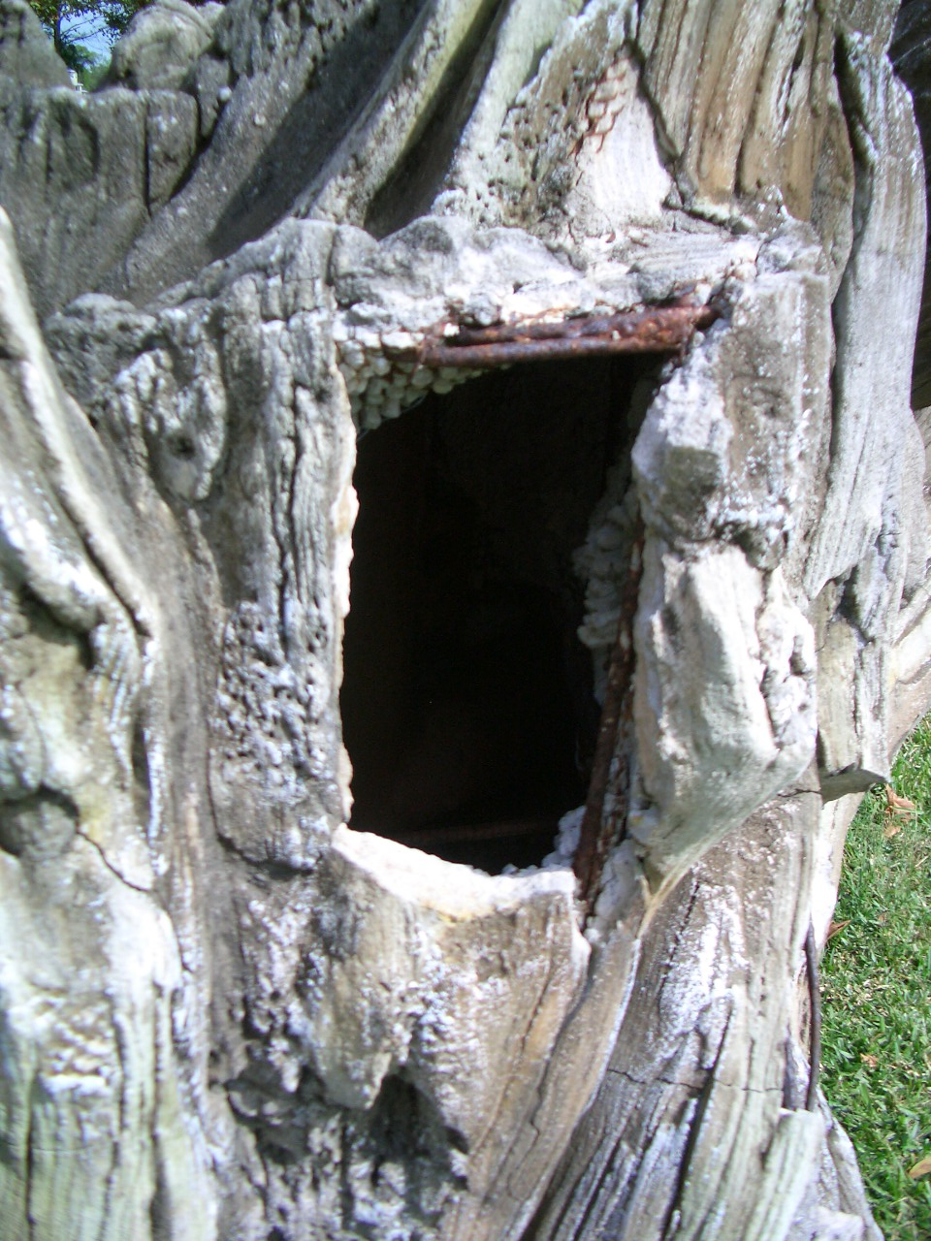

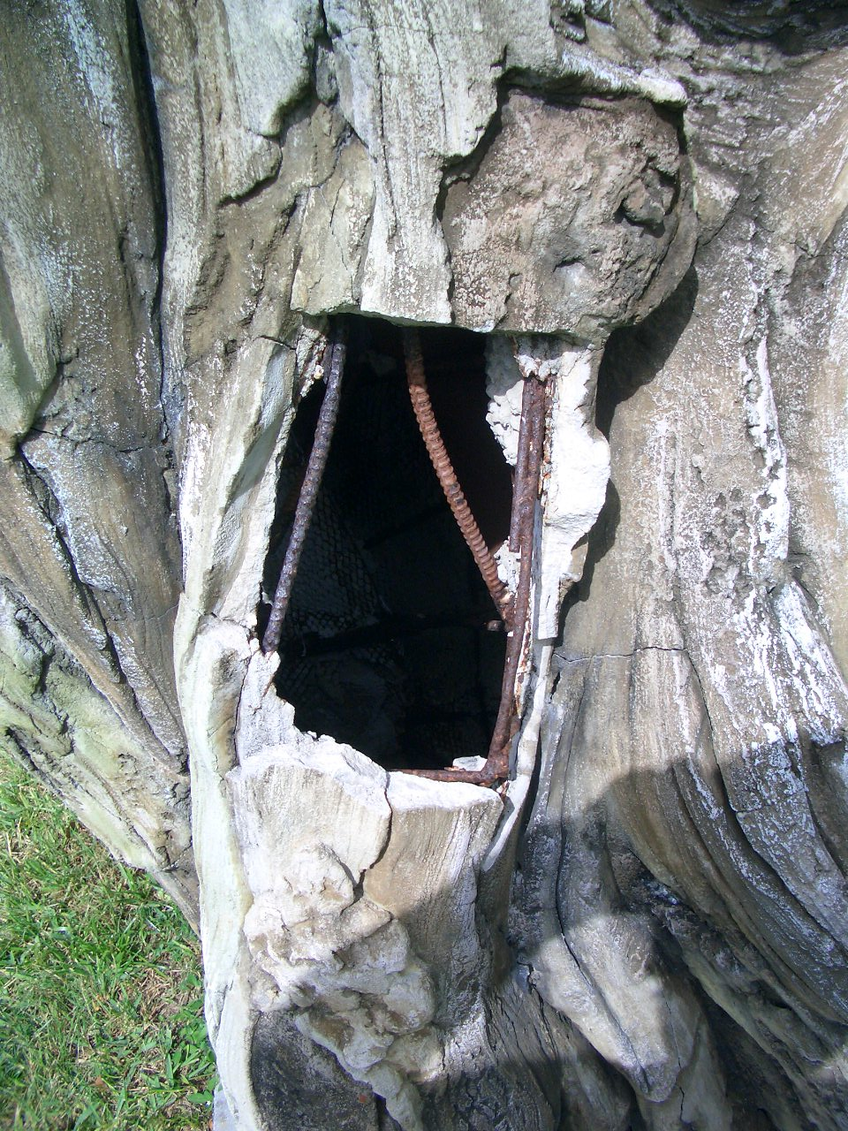

[**Shrubbery On Five Oaks Drive West Of Club House**](HarmonyBush-Location.pdf)

[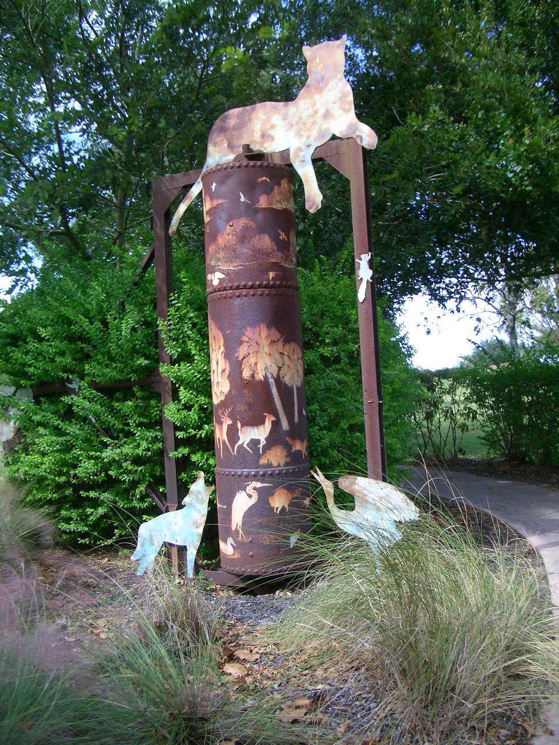](HarmonyBush-Location.pdf)

[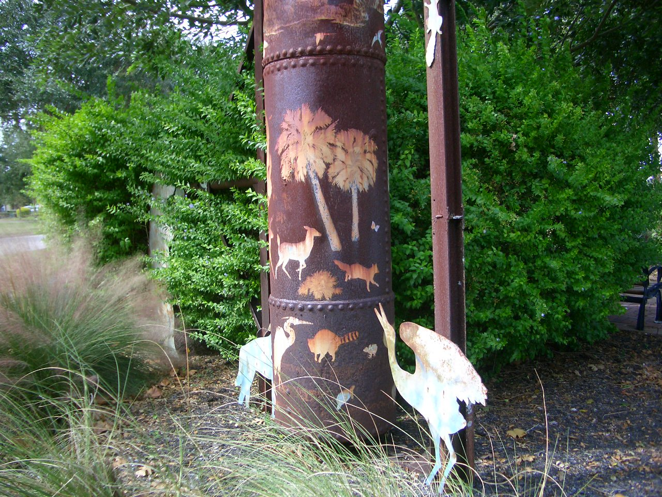](HarmonyBush-Location.pdf)

[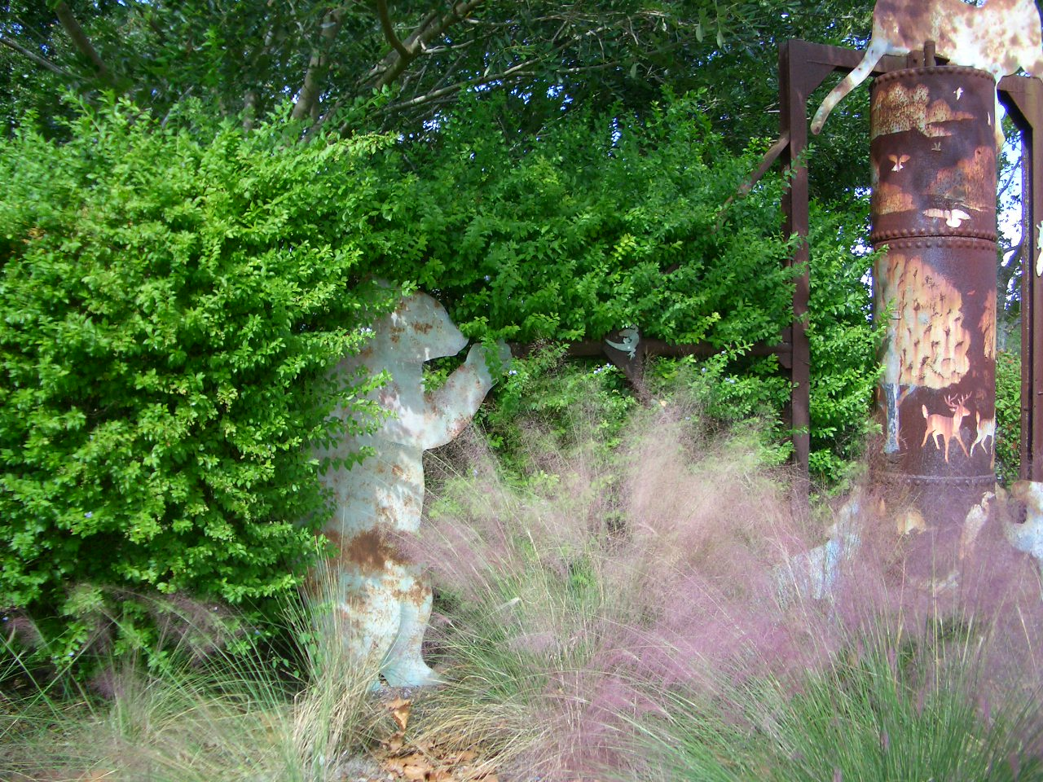](HarmonyBush-Location.pdf)